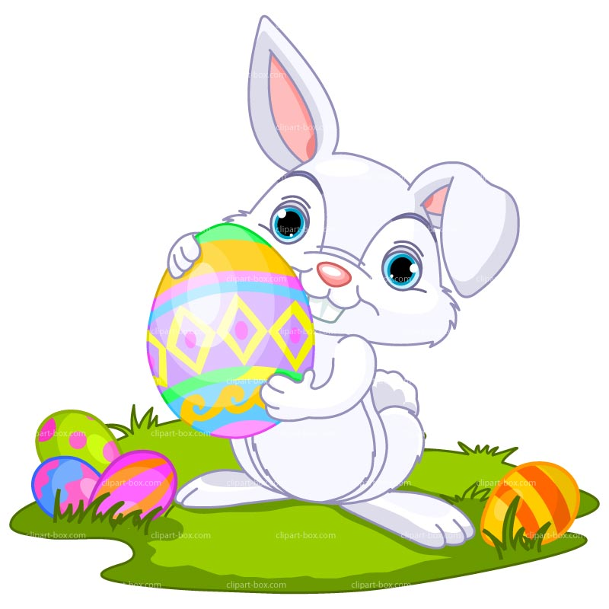
EASTER EGG SCAVENGER HUNT
Rules and Regulations
- Cost is $25 per vehicle/entry. Registration includes one (1) chocolate/candy bag however additional bags may be purchased when registering at a cost of $5 per bag. Please indicate if there are any nut allergies in your group.
- Registration is available online at rotarynutana.org. Click on the Scavenger Hunt Registration button on the main menu bar. Registration closes April 1, 2021.
- All clues are accessible by vehicle however you will need to have one member exit the vehicle to retrieve your Easter egg at each location. Please ensure that social distancing is being maintained to protect yourself and others and that you are wearing a mask. The Rotarians at each location will place an egg on a chair 6 ft away for you to retrieve.
- Each Easter egg will contain a small kid friendly prize. These prizes will include stickers, crayons, erasers, dinosaurs, etc. There are NO edible prizes in the eggs.
- In addition to these small prizes, you will have the opportunity to win a variety of other prizes from our sponsors. These prizes will range from entry to family fun centres, events and more. A full list of prizes will be posted on our website and on our Facebook page (Saskatoon Nutana Rotary Club) once all prizes are finalized. Within the eggs you may find a sponsor’s logo. You will be collecting these throughout the scavenger hunt. Each logo corresponds to the prize donated by that sponsor.
- If you collect one or two of the same logo, and there is no instant winner for the corresponding prize, then your name will be entered into the draw to win the corresponding prize. You must collect 3 of the same logo to be an instant winner of that prize.
- The Scavenger Hunt will run from 12pm to 4 pm on Sunday, April 4, 2021. There is no particular order to the clues or locations. After 4 pm, there will be no Rotarian at the location with Easter eggs.
- At 4:15 we ask all participants who have received sponsor logos in their eggs to be at Rotary Park. We will hold the final draws there. We ask that only one person per family or team come into the park for the draw, wearing a mask and social distancing from others. Please ensure your name is printed on the back of each of the sponsor logos ahead of time and put your entries into the appropriate sponsor’s draw box. If you have received three (3) of the same logo, please see a Rotarian at the draw station prior to any draws, failing which you will forfeit your instant win, however you will be eligible for the random draw for that prize. Names will then be randomly drawn until each sponsor’s prizes have been awarded. (If someone has an instant win for a particular sponsor and that sponsor only has one prize, there will be no further draws for that sponsor).
- Your clues to find each location will be emailed to you Saturday night April 3rd, by 9 pm so you can decipher your locations ahead of time. Should you not receive your instructions, please send an email to nutanarotary@gmail.com.
- You will receive 8 descriptions for family orientated areas within Saskatoon. Once you determine where these locations are, you will need to drive to each location. You are welcome to use google to help find these locations.
- At each location you will see an Easter garden stake or an Easter Egg Scavenger Hunt poster (and a Rotarian or two), so you will know you’re at the right location.
- Proceeds from the Easter Egg Scavenger Hunt will go to support breakfast programs within the community.
- Should you have any further questions or concerns, please do not hesitate to contact Candace Odishaw of the Saskatoon Nutana Rotary Club at nutanarotary@gmail.com.

CHOCOLATE/CANDY BAG SPONSORS:

PRIZE SPONSORS:
